Technical Briefing: Satellite Imagery Segmentation Pipeline for Slum Detection(FPN-VGG)

Executive Summary
This document provides a comprehensive technical overview of a deep learning pipeline designed to detect slum areas through satellite imagery segmentation. Utilizing a Feature Pyramid Network (FPN) with a VGG16 backbone, the model was trained over 30 epochs, ultimately achieving a peak validation F1 score of 0.9482. The methodology incorporates a hybrid loss function (Binary Cross Entropy and Dice Loss) and aggressive data augmentation techniques based on established research. Key performance indicators show a steady improvement in model accuracy, supported by a robust data pipeline that leverages local SSD synchronization and specialized preprocessing for multi-channel GeoTIFF images.
Dataset link: https://www.arcgis.com/home/item.html?id=e95daeb4085d4afb8ca81d0a1b11dce2
Research paper link: https://pdfs.semanticscholar.org/bc49/24f2e32d684372bf7aa10548205b77507a6c.pdf
Structure of dataset images:
- Dimensions: 400 pixels (Width) x 400 pixels (Height)
- Channels: 3 Bands
- Coordinate Reference System (CRS): EPSG:32643

Model Architecture and Training Methodology
The system employs a sophisticated deep learning architecture tailored for semantic segmentation of satellite imagery.
- Core Architecture: The model is a Feature Pyramid Network (FPN) utilizing a VGG16 encoder pre-trained on ImageNet. The configuration uses three input channels (RGB) and a single-class output with a sigmoid activation function to produce a probability mask.
- Loss Function: To optimize segmentation performance, the pipeline utilizes the Ardhitasari Hybrid Loss. This custom module combines:
  - Binary Cross Entropy (BCE): For pixel-wise classification.
  - Dice Loss: To handle class imbalance and improve spatial overlap accuracy.
- Optimization and Scheduling:
  - Optimizer: Adam optimizer with an initial learning rate of 1 \times 10^{-4}.
  - Scheduler: ReduceLROnPlateau was implemented to halve the learning rate (factor of 0.5) if the validation F1 score failed to improve for two consecutive epochs.
  - Gradient Accumulation: To simulate a larger batch size on constrained hardware, the pipeline used 4 accumulation steps, resulting in an effective batch size of 32 (8 images per batch \times 4 steps).

Training Performance and Validation
The training logs indicate a highly successful optimization process over 30 iterations.

Performance Metrics Table
Epoch | Train Loss | Val F1 Score | Status
1 | 0.7500 | 0.9262 | New Best Model
10 | 0.7325 | 0.9351 | -
20 | 0.7234 | 0.9410 | -
25 | 0.7283 | 0.9469 | New Best Model
30 | 0.7189 | 0.9482 | Final Best Model

Key Observations
- Convergence: The model showed rapid initial learning, surpassing an F1 score of 0.92 within the first epoch.
- Stability: Despite minor fluctuations in training loss (ranging from approximately 0.7189 to 0.7500), the validation F1 score maintained a consistent upward trajectory.
- Learning Rate Adjustment: At Epoch 29, the learning rate was reduced from 0.000100 to 0.000050, contributing to the final performance peak in Epoch 30.
- Final Accuracy: The best model was saved at Epoch 30 with a validation F1 score of 0.9482.

Data Engineering and Pipeline
The pipeline includes a specialized data management strategy to handle the heavy computational load of satellite imagery.

Data Synchronization and Splitting
- Local SSD Syncing: To bypass I/O bottlenecks associated with cloud storage, the pipeline syncs imagery and labels from Google Drive to a local SSD environment before processing.
- Data Partitioning: The dataset is divided into three distinct sets:
  - Training: 80%(1858 images)
  - Validation: 10%(232 images)
  - Testing: 10%(233 images)

Preprocessing and Augmentation
The pipeline uses the rasterio library to handle .tif files and albumentations for real-time data transformation.
- Normalisation: Images are normalized to 8-bit (0-255) and subsequently scaled to a float range of [0.0, 1.0] for the PyTorch tensors.
- Resizing: All inputs are resized to 256 \times 256 pixels to ensure compatibility with the encoder's downsampling layers.
- Augmentations: Drawing from Ardhitasari (2023) research in Mumbai, the training process includes:
  - Horizontal and Vertical Flips.
  - Random 90-degree rotations.
  - Shift, Scale, and Rotate transformations.
  - Random Brightness and Contrast adjustments.

Inference and Visualization
The inference stage is designed to apply the trained weights to new, unseen satellite tiles.
- Channel Management: While satellite imagery often contains four or more bands, the preprocessing function extracts the first three channels (RGB) to match the model’s expected input.
- Thresholding Strategy: While 0.5 is the standard threshold for binary masks, the pipeline documentation suggests that lower thresholds, specifically 0.45, may yield better results in identifying slum boundaries.
- Metadata Extraction: The pipeline utilizes rasterio to maintain awareness of spatial metadata, including:
  - Coordinate Reference Systems (CRS).
  - Resolution (units per pixel).
  - Origin and Transform data.
- Visualization: The pipeline generates side-by-side comparisons of the original satellite image, the ground truth label, and the model's predicted binary mask to facilitate qualitative assessment.
Testing on images from same dataset of which is used in training
Model loaded

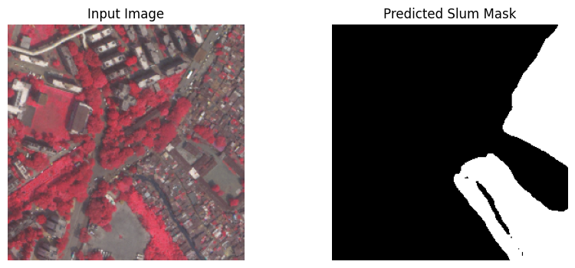
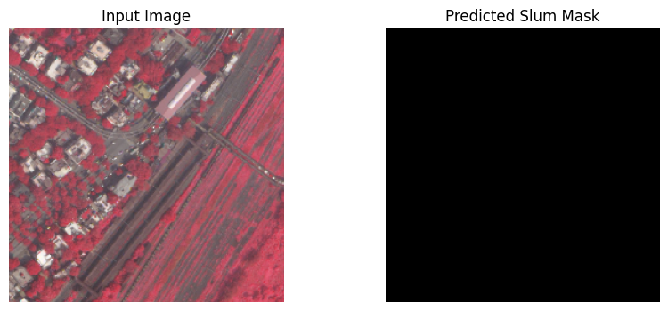
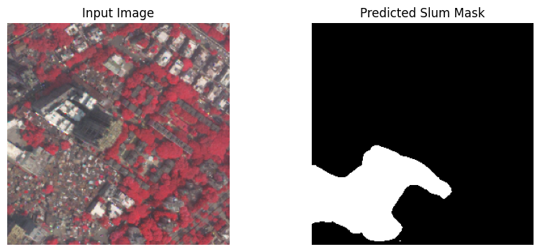
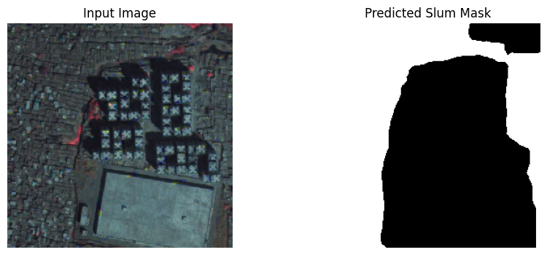
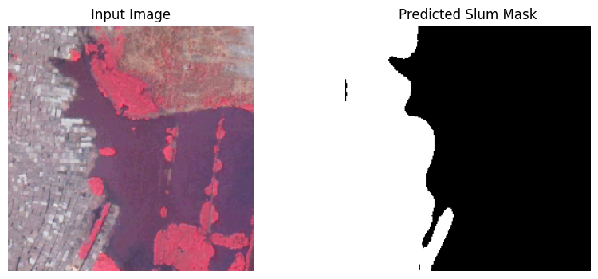
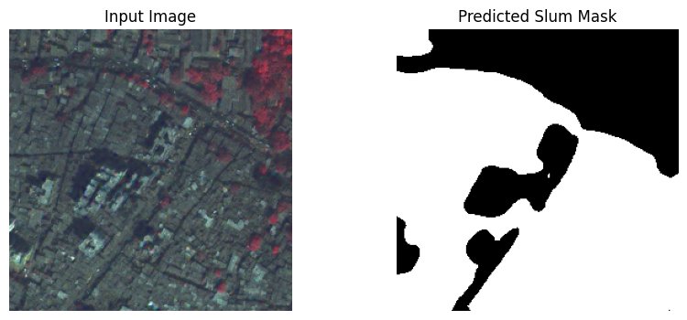
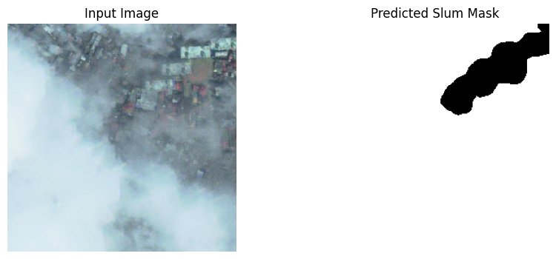

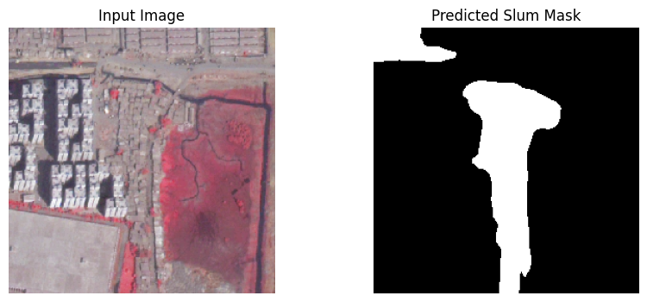
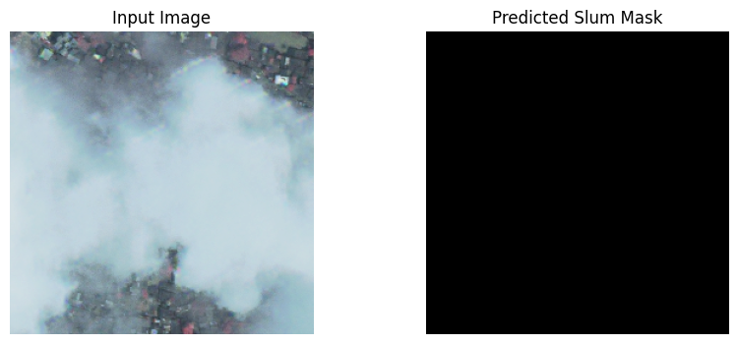
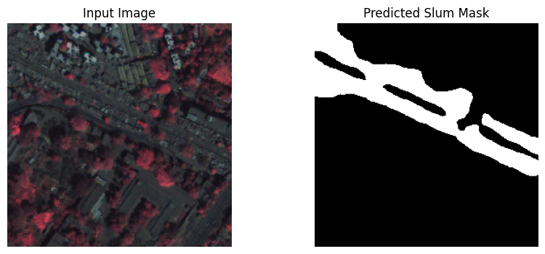
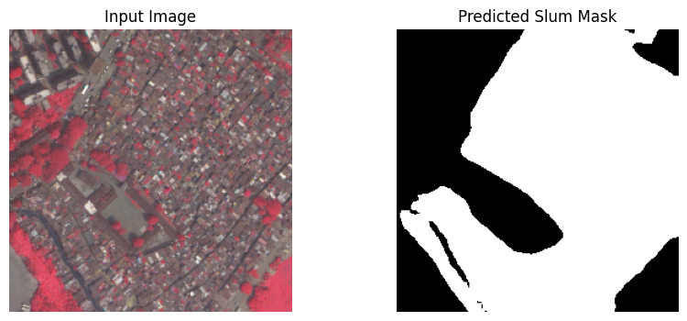
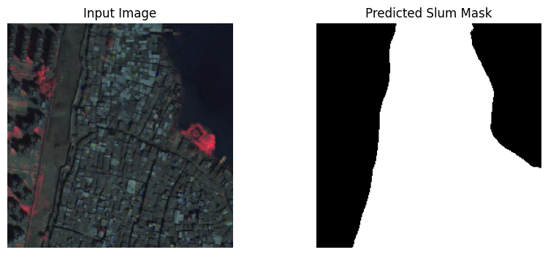
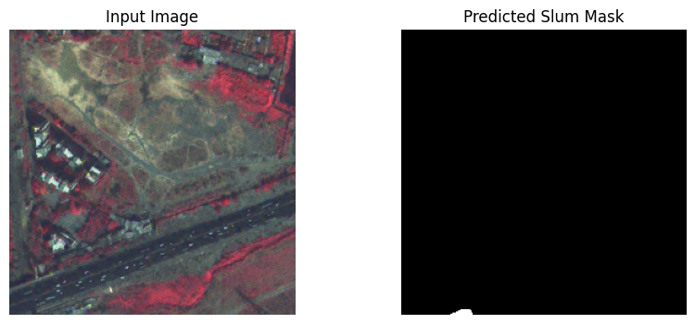
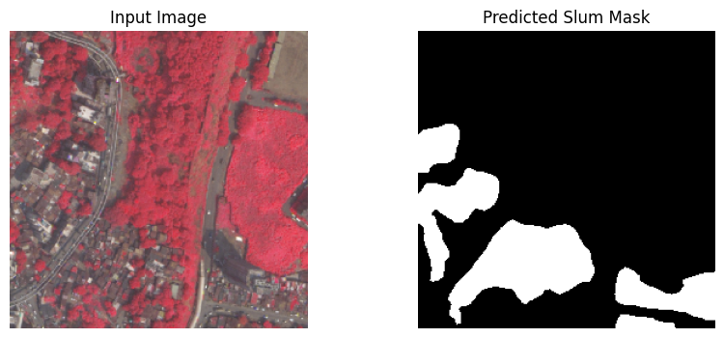

Testing on images other than training dataset:structure of this images(Image width: 600 pixels
Image height: 600 pixels
Number of bands (channels): 4
Image CRS (Coordinate Reference System): EPSG:32643)

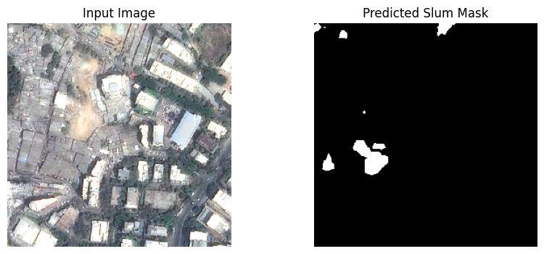

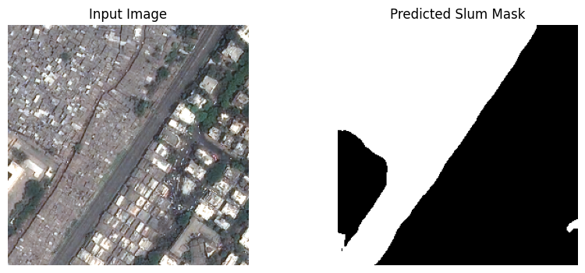
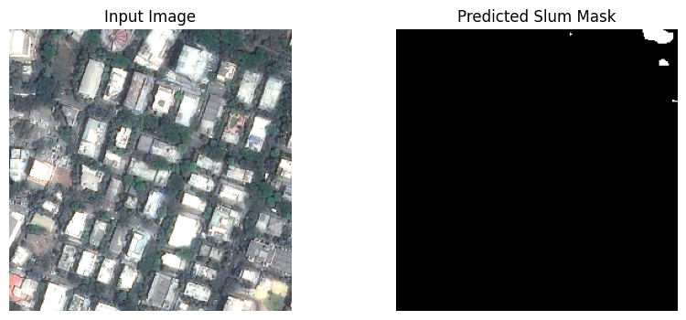
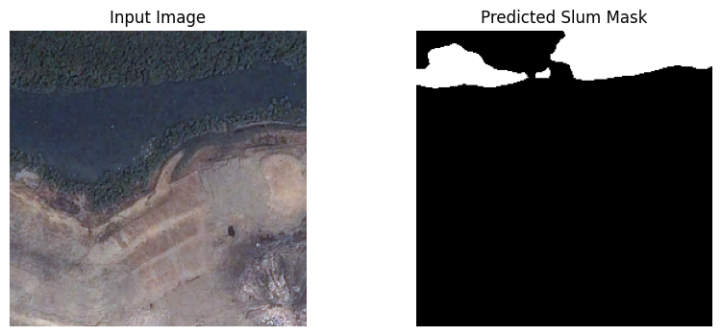
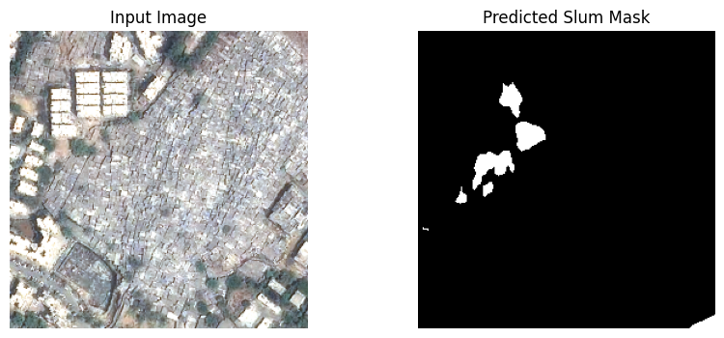
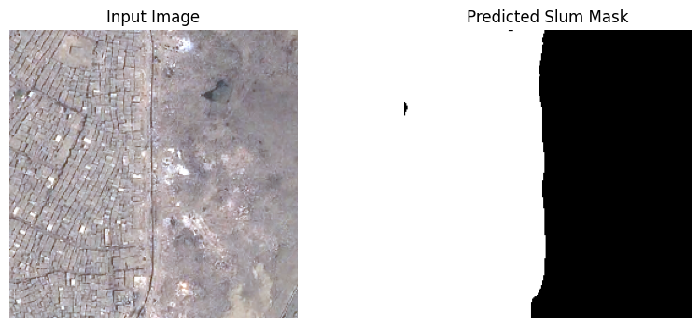
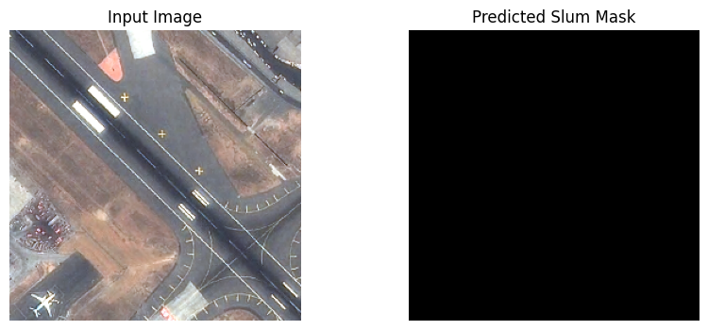
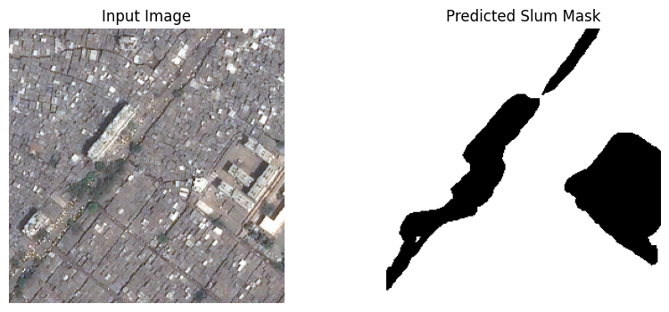
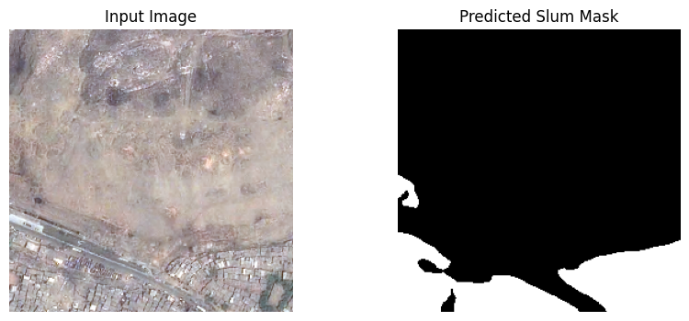
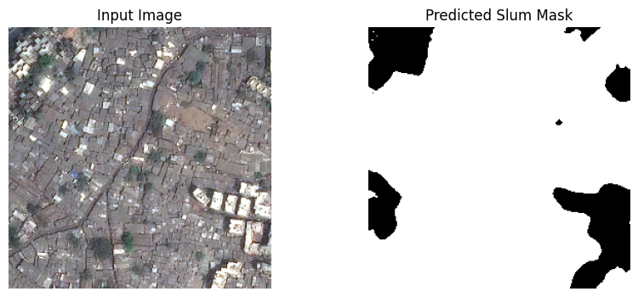
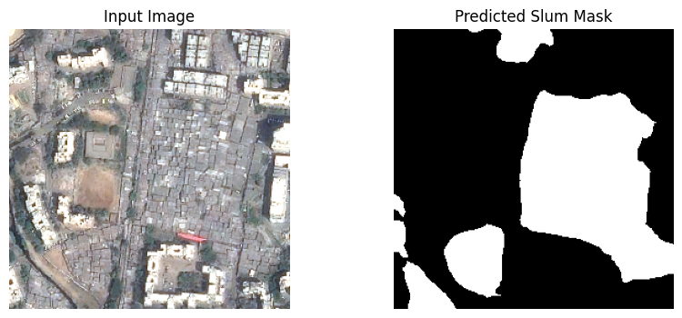
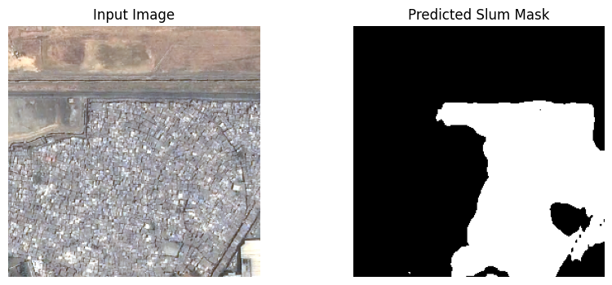
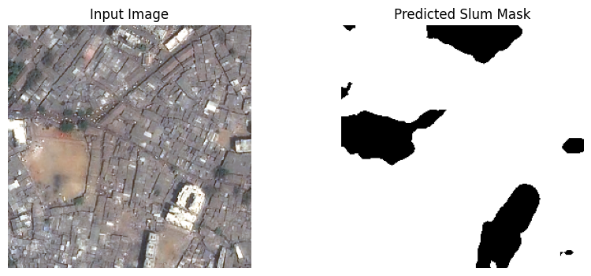
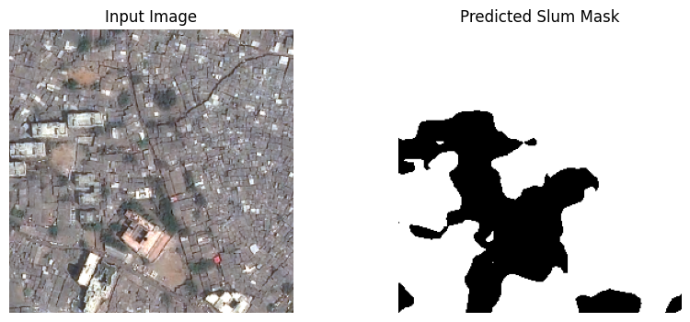
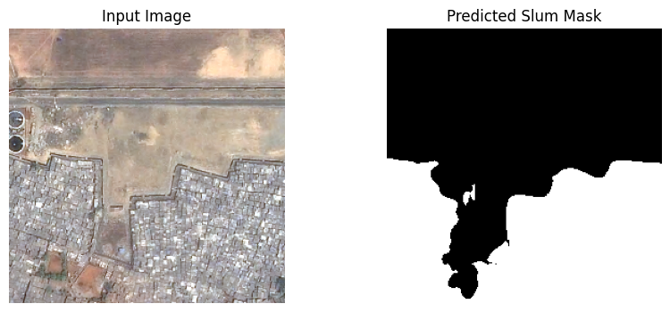
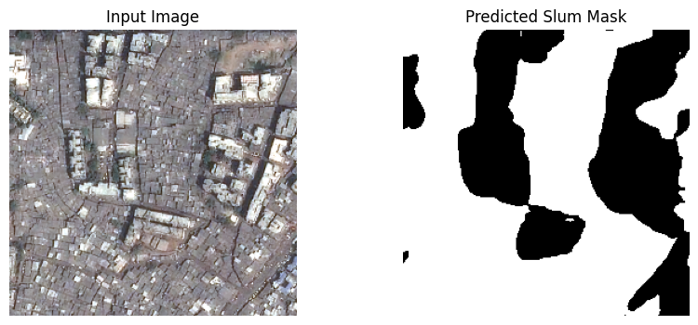
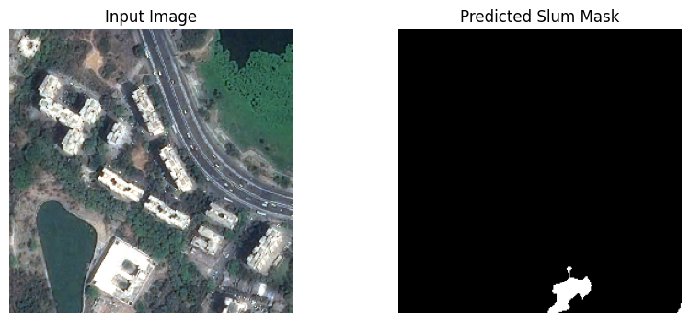
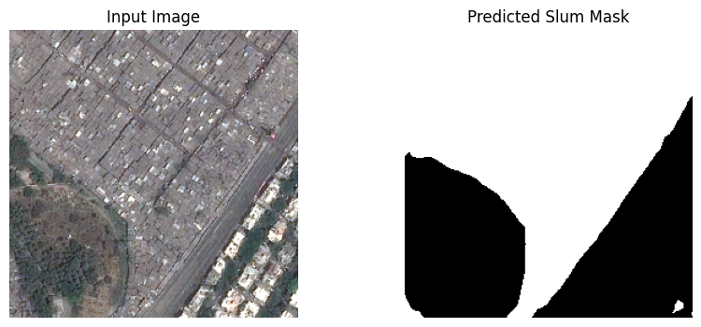
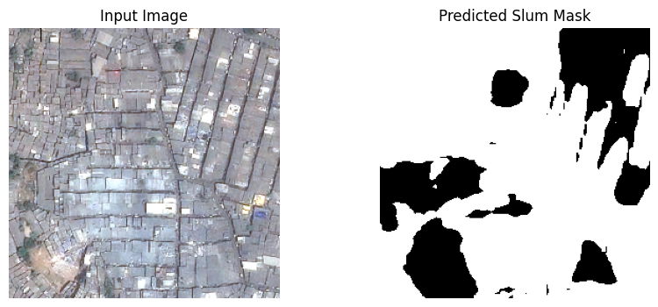
Tiff images i downloaded from sam:
From this notebook :https://colab.research.google.com/github/opengeos/segment-geospatial/blob/main/docs/examples/automatic_mask_generator.ipynb#scrollTo=GaUuELD07k9o
